**TIME SERIES ANALYSIS**

**TOPIC: PREDICTING THE FUTURE OF THE INDIAN RUPEE IN TERMS OF THE AMERICAN DOLLAR**

**By**

**Nisha Muthukumaran**

**Introduction:**

Over the past it has been observed that the value Indian rupees (INR) has been decreasing when compared to the American dollar(USD). For the record, the rupee was never equal to the dollar. Post-independence a rupee-dollar rate in 1947 was around Rs.3.30. The year 1976 saw a huge depreciation of INR, which again repeated in 1991 and then later 2000’s. Due to stagnant reforms, and declining foreign investment, rupee started depreciating more in the early 2013. The data set that was analyzed contains monthly conversion rates from March 2008 up until March 2018.

**1. ARIMA MODEL**

The data was converted to a time series and was split into test and train.

Test data - March 2008 – Sept 2018

Train data- October 2017 – March 2018(6 months)

The prediction is done for 6 months.

**Step1:** Visualize the data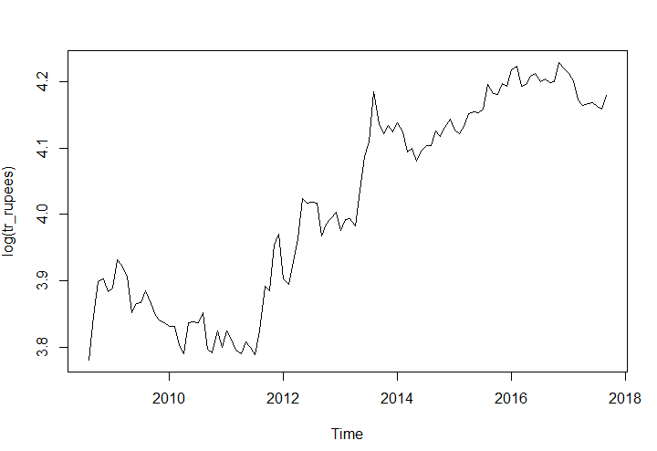

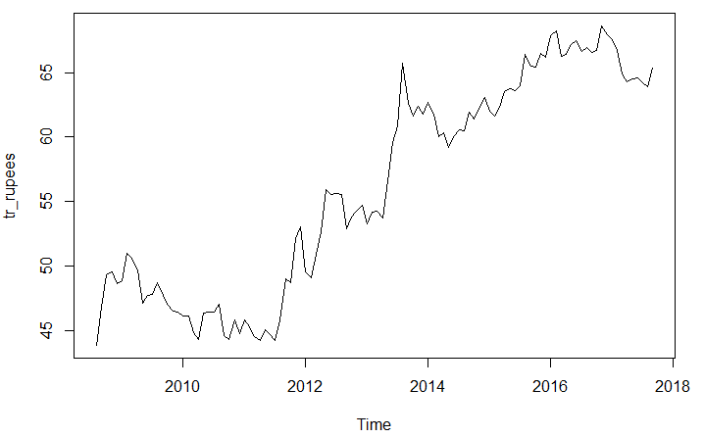

LOG

DIFF

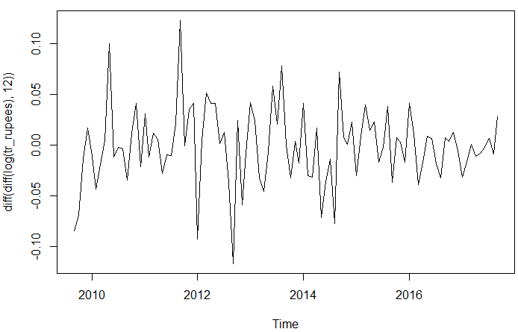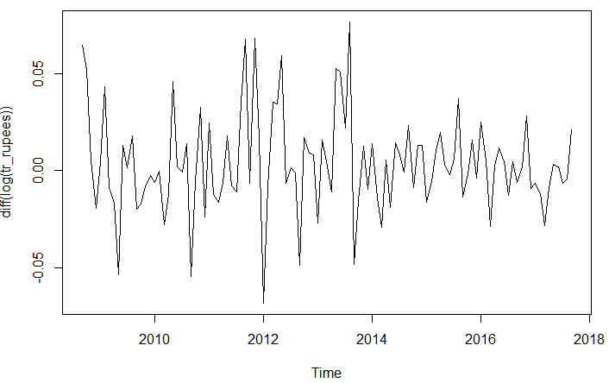

DIFF

**Step 2:** Stationarity

Checking the time series for stationarity with the help of the ADF test.

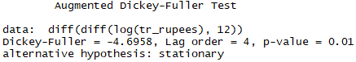

The training data was then checked for stationarity. It is stationary as the p-value is very small.

**Step 3:** Check ACF and PACF

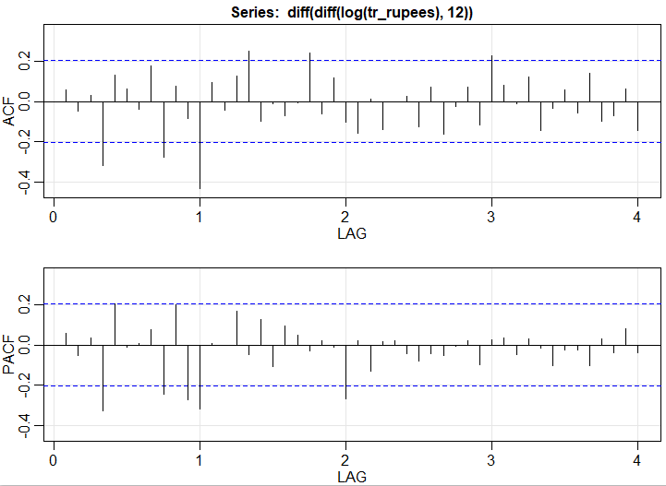

ACF seasonal part: It is cutting off after Lag 1

ACF non-seasonal part: It is tailing off

PACF seasonal part: Cutting off after lag 2

PACF non-seasonal part: Tailing off

**Step 4:** Build the ARIMA model

When auto.arima is tried on the model, it suggests a (0,1,0) model. But various combinations of p,q,P,Q values are tried which finally results in a p=0,d=1,q=0,P=2,D=1,Q=1,S=12 model which results in the lowest AIC and BIC values.

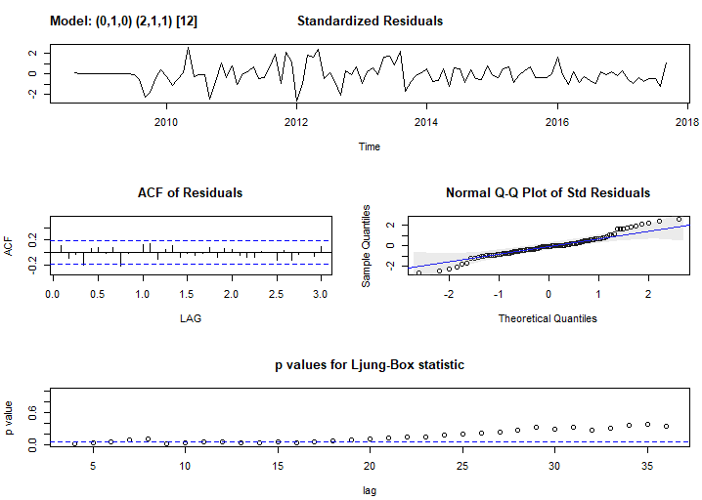

Residual analysis shows that there is no pattern (white noise) in the first graph, ACF of the residuals shows that the lines fall within the blue lines. The Q-Q plot shows that most of the variance is explained by the straight line and the p values fall above the blue line. This model gives the lowest AIC and BIC values of -6.43 and -7.36 respectively.

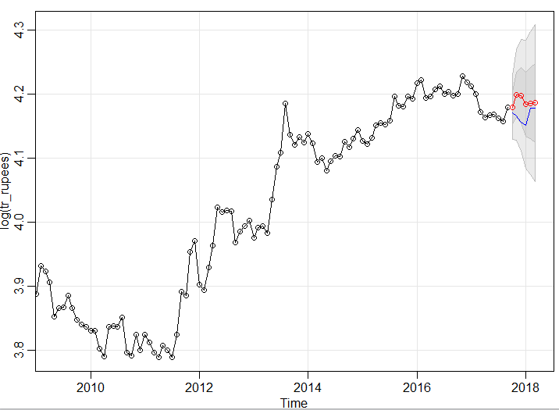**Step 5:** Forecast

On forecasting for 6 months ahead, the model gives a bad prediction with a **test** **set RMSE of 1.492846**. But the prediction does fall within the confidence range.

This model was further altered to remove the data points before 2014 and use 2014 Jan to 2018 Jan as a training set and predicting only 3 months ahead of time. But this did not improve the prediction nor did it improve the accuracy/lower the RMSE.

**2. EXPONENTIAL SMOOTHING**

The data was split into test and train data but this time the train data points from Jan 2012-Sept 2017 and test data from October 2017 to March 2018(6 months).

**Step 1**: Visualize the time series

The data is plotted from 2012 because excluding the “Great Depression” helps in improving the model predictions unlike in ARIMA.

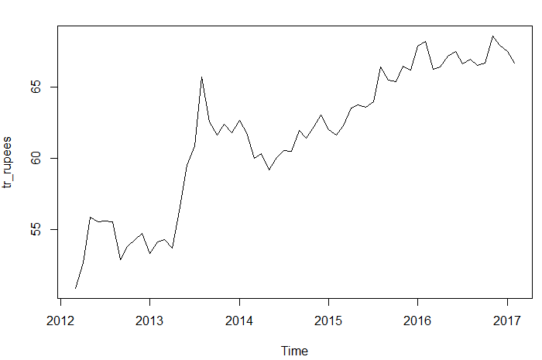

**Step 2:** Figure out if trend and/or seasonality exist + if seasonality is multiplicative or additive

A multiplicative seasonality and linear trend exists in the graphs which is why the method used is Holt‐Winter’s.

**Step 3:** Build the Exponential smoothing model + Forecast

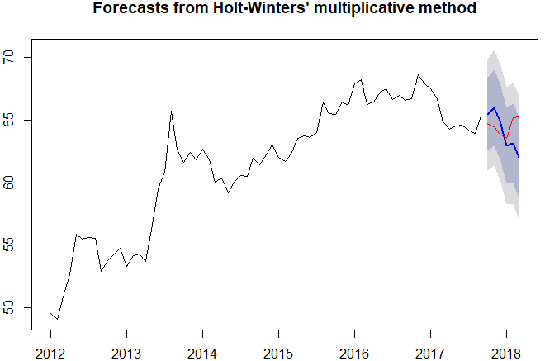

Test set **RMSE: 1.7735**

The error value is actually higher and the predictions are going in the downward direction. Probably excluding the years before 2014 might help in this case.

**Step 4:** Check residuals

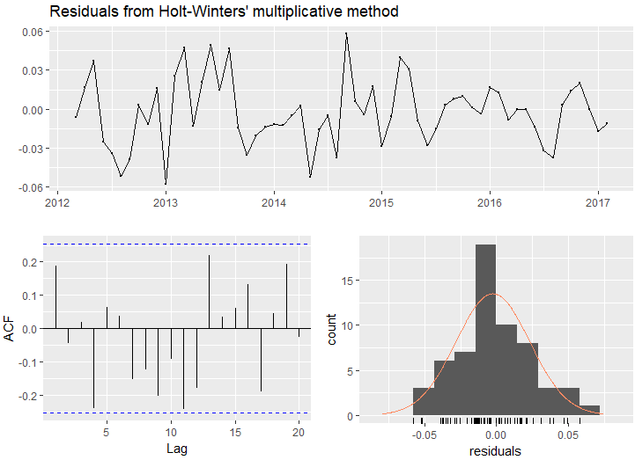

The first graph doesn’t have pattern in it (white noise). The ACF plot has the lines within the blue lines.

**3. PROPHET MODEL:**

Implements a procedure for forecasting time series data based on an additive model where non-linear trends are fit with yearly and weekly seasonality, plus holidays. The benefit of Prophet over other approaches is that it can be customized with holidays and events. works best with daily periodicity data with at least one year of historical data. Prophet is robust to missing data, shifts in the trend, and large outliers. Unlike other packages that will breakdown when passed an NA value with the historical data, Prophet will ignore those dates. It’s very accurate and fast. The model is resistant to the effects of outliers, and supports data collected over an irregular time scale (in gliding presence of missing data) without the need for interpolation. This package balances between simplicity, computation speed and the right amount of customization so both beginners and advanced users can use it.

The prediction was done for March 2018(1 Month prediction) onwards and the actual value was 65.22 and the predicted was 65.15. Prediction was also done for the past 6 months and the results are as below:

**REAL VALUES PREDICTED VALUES**

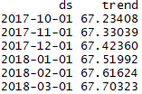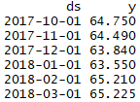

When the data points before 2012 were excluded and past 6 months prediction was done it was comparatively better:

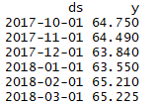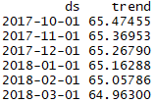 **REAL VALUES PREDICTED VALUES**

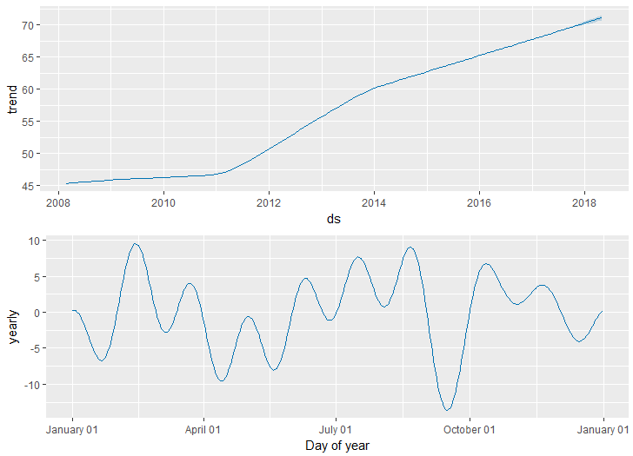

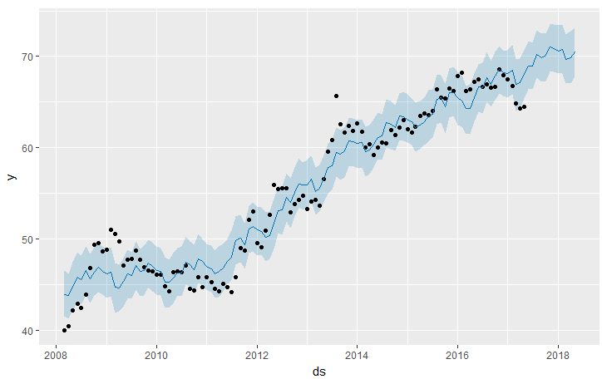

The advantage of this prophet package is that it handles the seasonality patterns and trends like it has shown in the graph above. It gave the better predictions out of the three models.